**PROGRAMMATION SCRATCH**

INTERFACE MBLOCK

SCENE

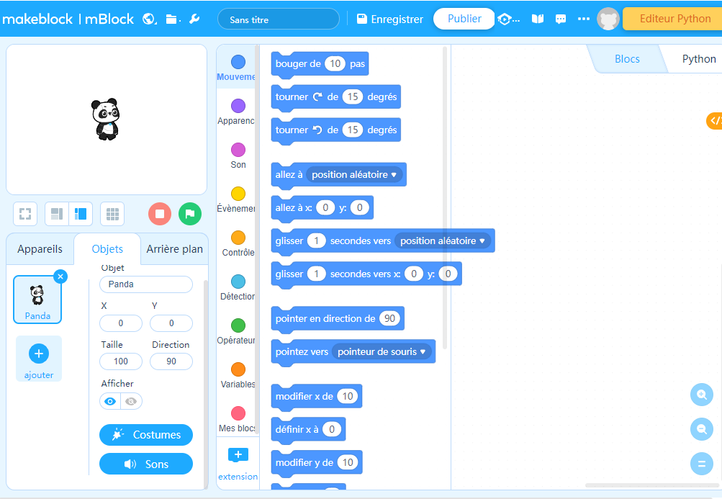

ZONE

PROGRAMMATION

Objets

Liste des objets

Blocs

Types de Blocs

Fond

Edition costumes

**PROGRAMMATION SCRATCH**

INTERFACE MBLOCK

SCENE



ZONE

PROGRAMMATION

Objets

Liste des objets

Blocs

Types de Blocs

Fond

Edition costumes

**PROGRAMMATION SCRATCH**

INTERFACE MBLOCK

_________

_________  
_________________

_______________

______________

_______________

______________

_____________

_____________

**PROGRAMMATION SCRATCH**

INTERFACE MBLOCK

_____________

_____________

______________

_______________

______________

_______________

_________  
_________________

_________